



Final Instructions No 1

Thank You for entering the Munster Car Club Moonraker Forestry 2012

Your seeded number is now available on www.munstercarclub.ie

Please note the following :

- Mechanical Scrutiny will take place in Horibrooks Toyota Dealer in Lismore from 15.30 to 20.30.

Documentation will be in the Nightclub of the Lismore House Hotel from 15.30 to 21.00. Entrance will be from the carpark at the rear of hotel. From Sunday morning the rally office will be located in the boardroom of the hotel.

Please ensure that all licences are current 2012 licences. NO IRDS. NO START, NO EXCEPTIONS!!!

- All cars must be in Parc Ferme by 21.00, this is located in Lismore Communnity Centre and Security will be provided.

- Trailer park will be provided in Lismore Business Park and a road book will be be given out at mechanical scrutiny.

- Cappoquin Service area; Cars 1-20 will service in Cappoquin Chickens and all other cars will service opposite Cappoquin Chickens. Competitors and Service Crews must remove litter from the Service Area and ground sheets must be used in both service areas.

- CLO for the event will now be Liam Moynihan and he can be contacted on 087 – 9291826.

- All named officials are Judges of Fact

- Drivers Briefing will take place on Sunday the 15th of April at 8.15am sharp in the nightclub of the Lismore House Hotel. It is compulsory for all competitors to attend

- No trailers are to be parked on hotel grounds.


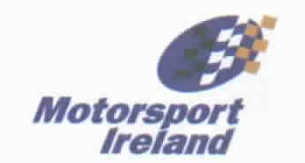
Yours In Motorsport

Colin Fitzgerald
Clerk Of The Course

