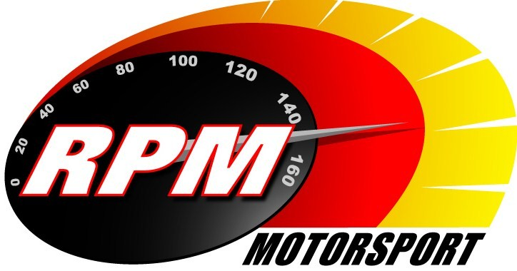
TV BILLINGS March 2012
Ireland’s Leading Motorsports Programme

UTV - Thursday 28th. March - 11.00pm.* - Donnelly Group Circuit of Ireland - Preview Rally I
Toni Kelly presents a preview of the famous Easter rally, which this year is a round of the Intercontinental Rally Challenge (IRC) and the Irish Tarmac Rally Championship. The programme includes highlights from the Azores & Grand Canaries rounds of the IRC and route details of the 2012 event. Andrew Bushe, Gary Gillespie, and Alan Tyndall report.

*Check with local papers for late schedule changes.

For further information contact:-
Paul McAuley Tyndall Productions 58 Edentrillick Road Hillsborough BT26 6PG. Tel 02892 689444. E-mail paul@rpm-motorsport.com

